|  |  |
| --- | --- |
|  |  |
| Catenary Programme | |
| User Manual | |
| December 22, 2018 | |



|  |  |  |  |  |  |
| --- | --- | --- | --- | --- | --- |
| Rev | Description | Date | Prep | Chk'd | Apprv'd |
| 01 | New Document |  |  |  |  |
|  |  |  |  |  |  |
|  |  |  |  |  |  |

Revision History

|  |  |  |  |
| --- | --- | --- | --- |
| Rev | Description | Section | Pages |
| 01 | New document | - | - |
|  |  |  |  |
|  |  |  |  |

CONTENTS

1 INTRODUCTION 3

2 Catenary 3

2.1 Catenary.yml 4

2.2 Catenary Methods.py 8

2.3 CatenaryRiser.py 16

2.4 Pipe Properties 20

2.5 CatenaryRiserSummary.py 23

3 Post- Process 25

3.1 Strength Analysis 25

3.1.1 OrcaFlex.yml 25

3.1.2 OrcaFlexAnalysis.py 26

3.1.3 Post Process.py 28

3.1.4 Post Process Plotting.py 28

3.2 Modal Analysis 28

3.2.1 Model Analysis.yml 28

3.2.2 Model Analysis.py 29

3.3 Fatigue Analysis 33

3.3.1 OrcaFlex_Fatigue.yml 33

3.3.2 OrcaFlexAnalysis_Fatigue.py 34

3.4 RAO’s 37

3.4.1 RAO.yml 37

3.4.2 RAO’s Analysis .py 39

3.4.3 RAO’s plotting 41

4 Common Code 43

4.1 Virtual Environment 43

4.2 Program Handling 44

4.3 Set Logging 44

4.4 Yaml 45

4.5 DataFrame to Image 46

4.6 DataFrame to Xlsx 47

4.7 Line Plot 49

4.8 Counter Plot 49

5 references 49

Appendix A – PROGRAM HISTORY 49

Appendix B - ERROR LOG 49

B.1 Calculation Errors 49

Appendix C -test cases. 49

# INTRODUCTION

TBA

# Summary

## Program Improvements

* Lazy wave equations should be improved so that each catenary should work very similar to how a simple catenary riser works.
* Lazy wave shape is determined based on using a particular internal fluid inside the riser. This internal fluid (eg. Production fluid) is defined in input using “LazyWaveCatenaryDefinition” and "configurationFluid"
  + The new lazy wave configuration for other internal fluids (seawater, empty, heavier production fluid etc.) should be determined by the program
  + A single plot showing all fluids will be very good plot.

|  |  |  |  |  |
| --- | --- | --- | --- | --- |
| **S.No** | Name | Description | Scope | Status |
| 1 | Input customization with infile dictionary |  | All algorithms |  |
| 2 | **kwargs |  | All algorithms |  |
| 3 | Wire up to common.config |  | catenary |  |
| 4 | Correct technical errors | Diameters,  Pipe types for taper jt and equivalent pipe  Axial drag formulas?  Is buoyancy diameter fixed? | Catenary |  |
| 5 | Pipe properties | Obtain from pipe.py | Catenary |  |
| 6 | Incorporate orcaflex 10.2 updates? |  | Catenary |  |
|  |  |  |  |  |

# Catenary

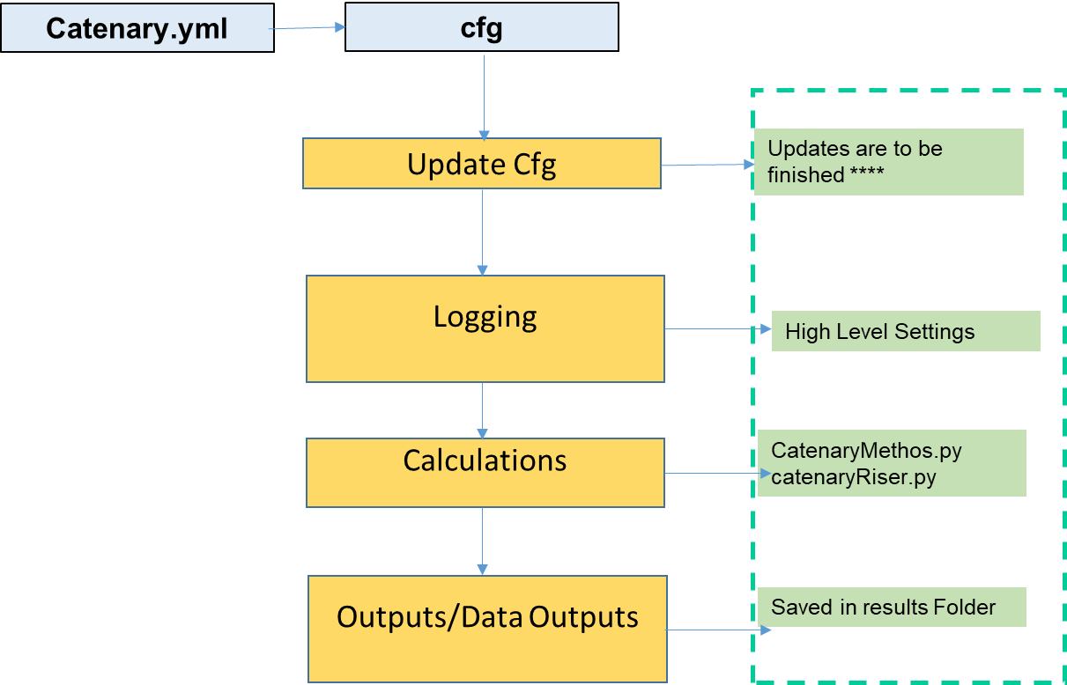

Figure 2‑1 Catenary Program Handling

## Catenary.yml

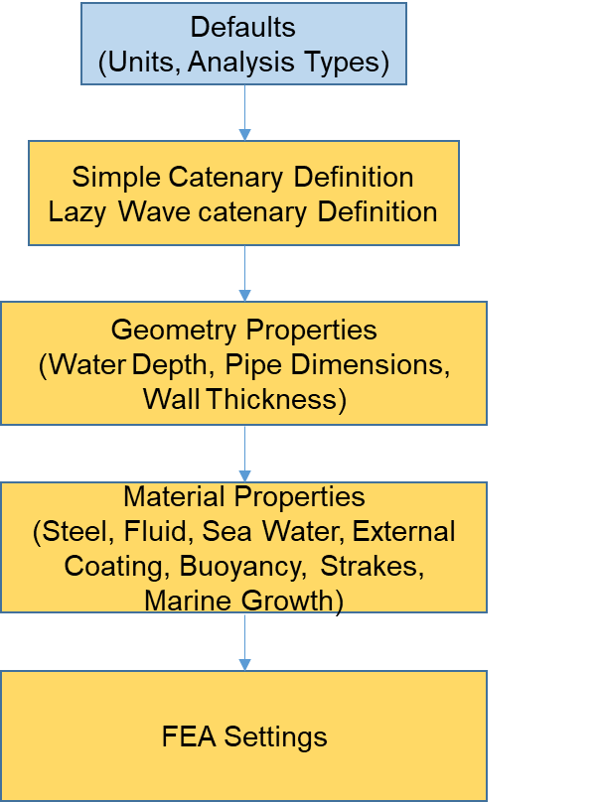

Figure 2‑2 Catenary.yml

|  |  |  |
| --- | --- | --- |
|  | Inputs | Description |
| Defaults | Analysis:  SCR : False  Jumper : False  SLWR : True  Extreme: True  Fatigue: False | We considering type of analysis for slwr  By giving the inputs statement True |
| Geometry | geometry:  waterDepth: 1347.2  NominalID: NULL  NominalOD: 8.625  DesignWT : 1.000  CorrosionAllowance: 0.236  ExternalCoating:  Thickness: 2.953  Strakes:  BaseThickness: 0.5906  Area: NULL  MarineGrowth:  Thickness: NULL | It is the given general geometry for pipe structure I.e. ID and OD and wall thickness  For pipe.in a particular depth towards the sea bed |
| Material Properties | Steel:  Rho: 7850  PoissionsRatio: 0.30  SMYS: 65300  SMUS: 77600  E: 30000000.00  G: 11538461.54  Fluid:  Rho: 400.4616  SeaWater:  Rho: 1025  ExternalCoating:  Rho: 800.9  Buoyancy:  Rho: 650  Strakes:  MassPerUnitLength: 21.5787  WeightPerUnitLength: -42.3375  Density: NULL  MarineGrowth:  Density: NULL | The type of material considered for the pipe  By taking the pre-defined values as inputs |
| Simple Catenary Definition | simpleCatenaryDefinition:  axialLineForce : NULL  verticalDistance : 1874.64  declinationAngle : 8 | Defining The Simple catenary Definition |
| Lazy Wave Catenary | LazyWaveCatenaryDefinition:  VerticalDistance : 1874.64  TDPToAnchor : 1500  HangoffBelowMeanSeaLevel : 0  HangoffAboveKeel : 11.21  SagBendElevationAboveSeabed : 731.52  HogBendAboveSeabed : 1097.28  declinationAngle : 8  UniformBuoyancy :  Thickness: NULL  BuoyancyFactor: 2  DiscreteBuoyancy:  Thickness: NULL  BuoyancyFactor: NULL  BuoyancyCoverage: 50  Spacing:  10  TaperJoint:  L: 9.144  ThickendThickness: 3.00 | Defining the lazy wave by giving the buoyancy parameters |

|  |  |  |
| --- | --- | --- |
| FEA Settings | FEASettings:  AnchorAdjustment: 54.36  Seabed:  FrictionCoefficient:  Normal: 0.6  Axial: 0.45  Stiffness:  Extreme: 10000  Fatigue: 1000  DesignPressure:  Surface: 750  TDP: NULL  Hydrodynamic:  Extreme:  MainPipe:  Ca: [1.5, '~', 0]  Cd: [1.5, '~', 0.008]  BuoyPipe:  Ca: [1, '~', 0.001]  Cd: [1, '~', 0.001]  BuoyPipeStartEnd:  Ca: [1, '~', 0.053570901]  Cd: [1, '~', 0.080356352]  Fatigue:  MainPipe:  Ca: [1.5, '~', 0]  Cd: [1.35, '~', 0.008]  BuoyPipe:  Ca: [1, '~', 0.001]  Cd: [0.9, '~', 0.001]  BuoyPipeStartEnd:  Ca: [1, '~', 0.053570901]  Cd: [1, '~', 0.080356352]  CorrosionAllowance:  Extreme: 0.236  Fatigue: 0.118  Damping:  Extreme:  Name: SteelDamping  Mode: Stiffness Proportional  DampingRatio: 0.5  Period1: '~'  ApplyToGeometricStiffness: No  Fatigue:  Name: SteelDamping  Mode: Stiffness Proportional  DampingRatio: 0.5  Period1: '~'  ApplyToGeometricStiffness: No  Mesh:  Top:  L: 25  Size: 0.5  Buoyancy:  L: NULL  Size: 2  BeforeTDP:  L: 250  Size: 1  AfterTDP:  L: 250  Size: 1  Stage:  Extreme:  Duration:  - 8  - 120  TargetLogSampleInterval: 0.3  ImplicitConstantTimeStep: 0.02  Fatigue:  Duration:  - 8  - 600  TargetLogSampleInterval: 0.3  ImplicitConstantTimeStep: 0.2  FlexJointStiffness: ConnectionLabel: FJProfile | Defining The FEA Settings |

## Catenary Methods.py

|  |  |  |
| --- | --- | --- |
| Inputs | Python Code | Description |
| Catenary Equation | def catenaryEquation(data):  if(data["F"] != None):  S = data["d"]*(2*data["F"]/data["w"]-data["d"])  #Horizontal Distance.  X=(((data["F"]/data["w"])-data["d"])*math.log((S+(data["F"]/data["w"]))/((data["F"]/data["w"])-data["d"])))  #weight of the suspended chain  W =(data["w"]*S)  #normalized horizontal tension component  THorizontal= (data["F"]*X/math.sqrt(S**2+X**2) #catenary shape parameter  b=(data["w"]*9.81/THorizontal)  data.update({"S": S, "X": X, "W": W, "THorizontal": THorizontal} return data  elif(data["q"] != None):  tanq = math.tan(math.radians(90 - data["q"]))  BendRadius = data["d"]*(math.cos(math.radians(90 - data["q"])))/(1-math.cos(math.radians(90 - data["q"])))  S = BendRadius * tanq  X = BendRadius * math.asinh(tanq)  data.update({"S": S, "X": X, "BendRadius": BendRadius})  return data | Defining the catenary equation |
| Catenary Force | def catenaryForces(data):  # Vertical load on vessel  Fv = data['weightPerUnitLength']*data['S']  # Total force along catenary  F = Fv/(math.sin(math.radians(90-data['q'])))  # Horizontal force along catenary  Fh = F*math.cos(math.radians(90-data['q']))  data.update({"Fv": Fv, "F": F, "Fh": Fh})  return data |  |
| Sag Elevation | def sagHogEquation(data):  # Sag to Buoyancy Configuration  BendRadius = data['HangOff']["BendRadius"]  d = (data['HogBendAboveSeabed']-data['SagBendElevationAboveSeabed'])*abs(data['WeightPerUnitLengthWithBuoyancy'])/(abs(data['WeightPerUnitLengthWithBuoyancy']) + abs(data['WeightPerUnitLengthWithOutBuoyancy']))  X = BendRadius*math.acosh(d/BendRadius + 1)  S = BendRadius*math.sinh(X/BendRadius)  data['SagToBuoyancy'] = {"d": d, "S": S, "X": X, "BendRadius" : BendRadius}  # Buoy to Hog Configuration  BendRadius = BendRadius*data['WeightPerUnitLengthWithOutBuoyancy']/(abs(data['WeightPerUnitLengthWithBuoyancy']))  d = (data['HogBendAboveSeabed']-data['SagBendElevationAboveSeabed'])*abs(data['WeightPerUnitLengthWithOutBuoyancy'])/(abs(data['WeightPerUnitLengthWithBuoyancy']) + abs(data['WeightPerUnitLengthWithOutBuoyancy']))  X = BendRadius*math.acosh(d/BendRadius + 1)  S = BendRadius*math.sinh(X/BendRadius)  data['BuoyancyToHog'] = {"d": d, "S": S, "X": X, "BendRadius" : BendRadius}  # Hog to Buoyancy Configuration  d = data['HogBendAboveSeabed']*abs(data['WeightPerUnitLengthWithOutBuoyancy'])/(abs(data['WeightPerUnitLengthWithBuoyancy']) + abs(data['WeightPerUnitLengthWithOutBuoyancy']))  X = BendRadius*math.acosh(d/BendRadius + 1)  S = BendRadius*math.sinh(X/BendRadius)  data['HogToBuoyancy'] = {"d": d, "S": S, "X": X, "BendRadius" : BendRadius}  # Buoyancy to TouchDown Configuration  BendRadius = data['HangOff']["BendRadius"]  d = data['HogBendAboveSeabed']*abs(data['WeightPerUnitLengthWithBuoyancy'])/(abs(data['WeightPerUnitLengthWithBuoyancy']) + abs(data['WeightPerUnitLengthWithOutBuoyancy']))  X = BendRadius*math.acosh(d/BendRadius + 1)  S = BendRadius*math.sinh(X/BendRadius)  data['BuoyancyToTouchDown'] = {"d": d, "S": S, "X": X, "BendRadius" : BendRadius}  return data |  |
| Lazy wave Catenary Equation | def lazyWaveCatenaryEquation(data):  # Hang-off to Sag Section  catenaryResult = catenaryEquation(data['HangOff'])  data['HangOff'].update(catenaryResult)  data = sagHogEquation(data)  # Summarize the lazy wave catenary  Fh = data['HangOff']["BendRadius"]*data['WeightPerUnitLengthWithOutBuoyancy']  Fv = Fh + data['WeightPerUnitLengthWithOutBuoyancy']*data['HangOff']["S"]  HangOffToBuoyancy = {"S" : data['HangOff']["S"] + data['SagToBuoyancy']["S"],  "X" : data['HangOff']["X"] + data['SagToBuoyancy']["X"]}  Buoyancy = {"S" : data['BuoyancyToHog']["S"] + data['HogToBuoyancy']["S"],  "X" : data['BuoyancyToHog']["X"] + data['HogToBuoyancy']["X"]}  BuoyancyToTouchDown = {"S" : data['BuoyancyToTouchDown']["S"], "X" : data['BuoyancyToTouchDown']["X"]}  HangoffToTDP = {"S" : HangOffToBuoyancy["S"] + Buoyancy["S"] + BuoyancyToTouchDown["S"],  "X": HangOffToBuoyancy["X"] + Buoyancy["X"] + BuoyancyToTouchDown["X"]}  data['Summary'] = { "HangOffToBuoyancy": HangOffToBuoyancy, "Buoyancy": Buoyancy, "BuoyancyToTouchDown": BuoyancyToTouchDown, "HangoffToTDP": HangoffToTDP, "Fh": Fh, "Fv": Fv}  # data['Summary'] = { "HangOffToBuoyancy": HangOffToBuoyancy}  return data |  |
| Lazy Wave Plot | def lazyWavePlot(data, spacing = 10):  # HangoffToBuoyancy Section  X=[]  Y=[]  BendRadius = data['lazyWaveCatenaryResult']['HangOff']['BendRadius']  HorizontalDistance = data['lazyWaveCatenaryResult']['HangOff']['X']  XRange = data['lazyWaveCatenaryResult']['Summary']["HangOffToBuoyancy"]['X']  XCoordinateAdjustment = 0  YCoordinateAdjustment = (BendRadius + data['lazyWaveCatenaryResult']['HangOff']['d'] \  + data['LazyWaveCatenaryDefinition']['HangoffBelowMeanSeaLevel'])  for i in range(0, spacing+1, 1):  X.append(XCoordinateAdjustment + i*XRange/spacing)  Y.append(BendRadius*(math.cosh((X[i] - HorizontalDistance)/BendRadius)) \  - YCoordinateAdjustment)  data['lazyWaveCatenaryResult']['Summary']["HangOffToBuoyancy"]['PlotData'] = {"X": X, "Y": Y}  PlotData = {"X": X, "Y": Y, "label": "Hang-off to Buoyancy", "SaveAndShow": False} genericPlot(PlotData) |  |
| Buoyancy Section | # Buoyancy Section  X=[]  Y=[]  BendRadius = data['lazyWaveCatenaryResult']['BuoyancyToHog']['BendRadius']  HorizontalDistance = data['lazyWaveCatenaryResult']['HangOff']['X'] \  +data['lazyWaveCatenaryResult']["SagToBuoyancy"]['X'] \  + data['lazyWaveCatenaryResult']["BuoyancyToHog"]['X']  XCoordinateAdjustment = data['lazyWaveCatenaryResult']['HangOff']['X'] \  + data['lazyWaveCatenaryResult']["SagToBuoyancy"]['X']  XRange = data['lazyWaveCatenaryResult']['Summary']["Buoyancy"]['X']  YCoordinateAdjustment = -BendRadius + data['lazyWaveCatenaryResult']['HangOff']['d'] \  - (data['LazyWaveCatenaryDefinition']['HogBendAboveSeabed'] \  - data['LazyWaveCatenaryDefinition']['SagBendElevationAboveSeabed']) \  + data['LazyWaveCatenaryDefinition']['HangoffBelowMeanSeaLevel']  for i in range(0, spacing+1, 1):  X.append(XCoordinateAdjustment + XRange*i/spacing)  Y.append(-BendRadius*(math.cosh((-X[i] + HorizontalDistance)/BendRadius)) \  - YCoordinateAdjustment)  data['lazyWaveCatenaryResult']['Summary']["Buoyancy"]['PlotData'] = {"X": X, "Y": Y}  PlotData = {"X": X, "Y": Y}  PlotData = {"X": X, "Y": Y, "label": "Buoyancy", "SaveAndShow": False}  genericPlot(PlotData) |  |
| Buoyancy To Touch Down | # BuoyancyToTouchDown Section  X=[]  Y=[]  BendRadius = data['lazyWaveCatenaryResult']["BuoyancyToTouchDown"]['BendRadius']  HorizontalDistance = data['lazyWaveCatenaryResult']['Summary']['HangoffToTDP']['X']  XCoordinateAdjustment = data['lazyWaveCatenaryResult']['Summary']['HangoffToTDP']['X'] \  - data['lazyWaveCatenaryResult']["BuoyancyToTouchDown"]['X']  XRange = data['lazyWaveCatenaryResult']['BuoyancyToTouchDown']['X']  YCoordinateAdjustment = (BendRadius + data['LazyWaveCatenaryDefinition']['HogBendAboveSeabed'] \  + data['LazyWaveCatenaryDefinition']['HangoffBelowMeanSeaLevel'])  for i in range(0, spacing+1, 1):  X.append( XCoordinateAdjustment + XRange*i/spacing)  Y.append(BendRadius*math.cosh((X[i] - HorizontalDistance)/BendRadius) \  - BendRadius - data['LazyWaveCatenaryDefinition']['VerticalDistance'] \  - data['LazyWaveCatenaryDefinition']['HangoffBelowMeanSeaLevel'])  data['lazyWaveCatenaryResult']['Summary']["BuoyancyToTouchDown"]['PlotData'] = {"X": X, "Y": Y}  PlotData = {"X": X, "Y": Y, "label": "Buoyancy to TDP", "SaveAndShow": True, "fileName": "results\\" + "SLWR_" + data['FileName']} genericPlot(PlotData)  return data |  |
| Generic Plot | def genericPlot(data):  if data["label"] == None:  plt.plot(data["X"], data["Y"])  else:  plt.plot(data["X"], data["Y"], label=data["label"])  #it creates plot X-axis name, fontsize and colour  plt.xlabel('Horizontal distance[m]', fontsize=12, fontweight='bold', color='black')  #it creates plot Y-axis name, fontsize and colour  plt.ylabel('Distance from seabed [m]', fontsize=12, fontweight='bold', color='black')  #it creates plot tittle, color and size  plt.title('Catenary Mooring Line Shape',fontsize=14, fontweight='bold', color='black')  # Gridlines  plt.grid()  if(data['SaveAndShow'] == True):  plt.savefig(data["fileName"].replace(".", ""), dpi=800)  plt.legend(loc='upper center', bbox_to_anchor=(0.5, -0.05),  fancybox=True, shadow=True, ncol=5) |  |
| Buoyancy properties | def buoyancyProperties(cfg):  if cfg["LazyWaveCatenaryDefinition"]["UniformBuoyancy"]["Thickness"] != None:  cfg = pipeProperties(cfg, FluidDensity=cfg['Material']['Fluid']['Rho'], Buoyancy = True)  WeightPerUnitLengthWithBuoyancy = cfg['equivalentPipe']['weightPerUnitLength']  cfg["LazyWaveCatenaryDefinition"]["UniformBuoyancy"]["BuoyancyFactor"] = 1 - (WeightPerUnitLengthWithBuoyancy/WeightPerUnitLengthWithOutBuoyancy)  # Add buoyancy Ratio and also buoyancy module detailed properties  elif cfg["LazyWaveCatenaryDefinition"]["UniformBoyancy"]["BuoyancyFactor"] != None: BuoyancyOD = math.sqrt(2*cfg['catenaryResult']['FluidFilled']['weightPerUnitLength']/9.81*4/math.pi/(cfg['Material']['SeaWater']['Rho'] \-cfg['Material']['Buoyancy']['Rho']) + (cfg['InsulationSection']['OD']*0.0254)**2)/0.0254 cfg["LazyWaveCatenaryDefinition"]["UniformBuoyancy"]["Thickness"] = (BuoyancyOD - cfg['InsulationSection']['OD'])/2  WeightPerUnitLengthWithBuoyancy = (1 - cfg["LazyWaveCatenaryDefinition"]["UniformBuoyancy"]["BuoyancyFactor"]) \  * cfg['catenaryResult']['FluidFilled']['weightPerUnitLength']  DiscreteBuoyancyOD = math.sqrt(100/cfg['LazyWaveCatenaryDefinition']['DiscreteBuoyancy']['BuoyancyCoverage'] * BuoyancyOD**2 - cfg['InsulationSection']['OD']**2)  cfg['LazyWaveCatenaryDefinition']['DiscreteBuoyancy']['Thickness'] = DiscreteBuoyancyOD  cfg['lazyWaveCatenaryResult'] = {}  cfg['lazyWaveCatenaryResult']['WeightPerUnitLengthWithOutBuoyancy'] = cfg['catenaryResult']['FluidFilled']['weightPerUnitLength']  cfg['lazyWaveCatenaryResult']['WeightPerUnitLengthWithBuoyancy'] = WeightPerUnitLengthWithBuoyancy  return cfg |  |

## CatenaryRiser.py

|  |  |  |
| --- | --- | --- |
| Inputs | Python Code | Description |
| Build Model | def BuildModel(FEAType):  if cfg['default']['Analysis']['SLWR']:  for LoadingIndex in range (0, len(cfg['EnvironmentLoad'][FEAType])):  cfg['fileName'] = 'results\\FEA\\' + FEAType + '\\' + 'SLWR_' + cfg['FileName'] + '_' + cfg['EnvironmentLoad'][FEAType][LoadingIndex]['Wave']['WaveTrains'][0]['Name'] + '.yml'  if cfg['default']['Analysis'][FEAType] == True:  FEAmodel1, FEAmodel2 = orcaflexModel(cfg, FEAType, LoadingIndex)  if FEAType == 'Extreme':  WriteOrcaflexModel([FEAmodel1, 'dataManager\\VesselTypes_Extreme.yml', FEAmodel2], cfg, FEAType, LoadingIndex) elif FEAType == 'Fatigue':  WriteOrcaflexModel([FEAmodel1, 'dataManager\\VesselTypes_Fatigue.yml', FEAmodel2], cfg, FEAType, LoadingIndex)  saveDataYaml(cfg, 'results\\' + 'SLWR_' + 'Summary_' + cfg['FileName'], False)  if cfg['default']['Analysis']['SCR']:  for LoadingIndex in range (0, len(cfg['EnvironmentLoad'][FEAType])):  cfg['fileName'] = 'results\\FEA\\' + FEAType + '\\' + 'SCR_' + cfg['FileName'] + '_' + cfg['EnvironmentLoad'][FEAType][LoadingIndex]['Wave']['WaveTrains'][0]['Name'] + '.yml'  if cfg['default']['Analysis'][FEAType] == True:  FEAmodel1, FEAmodel2 = orcaflexModel(cfg, FEAType, LoadingIndex)  if FEAType == 'Extreme':  WriteOrcaflexModel([FEAmodel1, 'dataManager\\VesselTypes_Extreme.yml', FEAmodel2], cfg, FEAType, LoadingIndex)  elif FEAType == 'Fatigue':  WriteOrcaflexModel([FEAmodel1, 'dataManager\\VesselTypes_Fatigue.yml', FEAmodel2], cfg, FEAType, LoadingIndex) saveDataYaml(cfg, 'results\\' + 'SCR_' + 'Summary_' + cfg['FileName']) | To build the extreme and fatigue analysis |
| Data Preparation | # Data preparation  defaultYml = "dataManager\\catenary.yml"  # Get updateYML file  try:  if (sys.argv[1] != None):  updateYml = "dataManager\\" + sys.argv[1]  logging.critical("Updating default values with contents in file {0}" .format(updateYml) )  except:  updateYml = None  logging.critical("No update values file is provided. Running program default values")  # Get updated configuration file for Analysis  cfg = ymlInput(defaultYml, updateYml)  try:  cfg['FileName'] = updateYml.split('\\')[1].split('.')[0]  except:  cfg['FileName'] = defaultYml.split('\\')[1].split('.')[0]  cfg = customUpdate(cfg) | Preparing the data preparation from the input yml file and updating the inputs from yml file. |
| Set Logging | # Set logging  setLogging(cfg['default']['logLevel'])  # Evaluate section properties and mass per unit length and related properties.  inputData = {"d": cfg["simpleCatenaryDefinition"]["verticalDistance"],  "F": cfg["simpleCatenaryDefinition"]["axialLineForce"],  "q" : cfg["simpleCatenaryDefinition"]["declinationAngle"]  }  catenaryResult = catenaryEquation(inputData)  cfg['catenaryResult'] = catenaryResult  cfg = pipeProperties(cfg, FluidDensity=cfg['Material']['Fluid']['Rho'], Buoyancy = False)  WeightPerUnitLengthWithOutBuoyancy = cfg['equivalentPipe']['weightPerUnitLength']  inputData = {'weightPerUnitLength' : cfg['equivalentPipe']['weightPerUnitLength'],  'S' : cfg['catenaryResult']['S'],  'q' : cfg['catenaryResult']['q']  }  output = catenaryForces(inputData)  cfg['catenaryResult']['FluidFilled'] = output  cfg = pipeProperties(cfg, FluidDensity=cfg['Material']['SeaWater']['Rho'], Buoyancy = False)  inputData = {'weightPerUnitLength' : cfg['equivalentPipe']['weightPerUnitLength'],  'S' : cfg['catenaryResult']['S'],  'q' : cfg['catenaryResult']['q']  }  output = catenaryForces(inputData)  cfg['catenaryResult']['SeaWaterFilled'] = output  cfg = pipeProperties(cfg, FluidDensity=0, Buoyancy = False)  inputData = {'weightPerUnitLength' : cfg['equivalentPipe']['weightPerUnitLength'],  'S' : cfg['catenaryResult']['S'],  'q' : cfg['catenaryResult']['q']  }  output = catenaryForces(inputData)  cfg['catenaryResult']['Empty'] = output |  |
| Lazy Wave Analysis | # Lazy Wave Analysis  cfg = buoyancyProperties(cfg)  lazyWaveInputs = {"WeightPerUnitLengthWithBuoyancy": cfg['lazyWaveCatenaryResult']['WeightPerUnitLengthWithBuoyancy'],  "WeightPerUnitLengthWithOutBuoyancy": cfg['lazyWaveCatenaryResult']['WeightPerUnitLengthWithOutBuoyancy'],  "SagBendElevationAboveSeabed": cfg['LazyWaveCatenaryDefinition']['SagBendElevationAboveSeabed'],  "HogBendAboveSeabed": cfg['LazyWaveCatenaryDefinition']['HogBendAboveSeabed'],  "HangOff": {"d": cfg['LazyWaveCatenaryDefinition']['VerticalDistance'] - cfg['LazyWaveCatenaryDefinition']['SagBendElevationAboveSeabed'],  "q": cfg["LazyWaveCatenaryDefinition"]["declinationAngle"], "F": None },  }  cfg['lazyWaveCatenaryResult'].update(lazyWaveCatenaryEquation(lazyWaveInputs))  cfg['lazyWaveCatenaryResult']['TotalBuoyancy'] = (cfg['lazyWaveCatenaryResult']['WeightPerUnitLengthWithBuoyancy'] - cfg['lazyWaveCatenaryResult']['WeightPerUnitLengthWithOutBuoyancy'])*cfg['lazyWaveCatenaryResult']['Summary']['Buoyancy']['S']  cfg = lazyWavePlot(cfg, cfg['LazyWaveCatenaryDefinition']['Spacing'])  # Construct FEA Model  cfg = pipeProperties(cfg, FluidDensity=0, Buoyancy = False)  cfg['MainPipe'] = {'SteelSection': cfg['SteelSection'], 'BuoyancySection': cfg['BuoyancySection'],  'InsulationSection': cfg['InsulationSection'], 'equivalentPipe': cfg['equivalentPipe']}  cfg = pipeProperties(cfg, FluidDensity=0, Buoyancy = True)  cfg['BuoyPipe'] = {'SteelSection': cfg['SteelSection'], 'BuoyancySection': cfg['BuoyancySection'],  'InsulationSection': cfg['InsulationSection'], 'equivalentPipe': cfg['equivalentPipe']}  if cfg['default']['Analysis']['Extreme']:  FEAType = 'Extreme'  BuildModel(FEAType)  if cfg['default']['Analysis']['Fatigue']:  FEAType = 'Fatigue'  BuildModel(FEAType) | Defining the lazy wave analysis |

## Pipe Properties

|  |  |  |
| --- | --- | --- |
| Inputs | Python Code | Description |
| Pipe properties For Fluid Density | def pipeProperties(cfg, FluidDensity, Buoyancy = False):  cfg = steelSectionProperties(cfg)  cfg = insulationSectionProperties(cfg)  if Buoyancy == True:  cfg = buoyancySectionProperties(cfg)  else: cfg['BuoyancySection'] = None  cfg = equivalentPipe(cfg, FluidDensity, Buoyancy)  return(cfg) | To define the pipe properties of steel section and insulation section properties. |
| Steel Properties | def steelSectionProperties(cfg):  OD = cfg["geometry"]["NominalOD"]  ID = cfg["geometry"]["NominalID"]  data = {"OD": OD, "ID": ID}  cfg['SteelSection'] = sectionProperties(data)  return cfg | Defining the steel section properties. |
| Insulation Section Properties | def insulationSectionProperties(cfg):  OD=cfg["geometry"]["NominalOD"]+2*cfg["geometry"]["ExternalCoating"]['Thickness']  ID = cfg["geometry"]["NominalOD"]  data = {"OD": OD, "ID": ID}  cfg['InsulationSection'] = sectionProperties(data) return cfg | Defining the insulation properties. |
| Buoyancy Section Properties | def buoyancySectionProperties(cfg):  OD = cfg['InsulationSection']["OD"]+2*cfg["LazyWaveCatenaryDefinition"]["UniformBuoyancy"]['Thickness']  ID = cfg['InsulationSection']["OD"]  data = {"OD": OD, "ID": ID}  cfg['BuoyancySection'] = sectionProperties(data)  return cfg | Defining the buoyancy properties |
| Section Properties | def sectionProperties(data):  A = (math.pi/4)*(data['OD']**2-data['ID']**2)  Ai = (math.pi/4)*(data['ID']**2)  Ao = (math.pi/4)*(data['OD']**2)  I = (math.pi/64)*(data['OD']**4-data['ID']**4)  data.update({"A": A, "Ai": Ai, "Ao": Ao, "I": I})  return data | Defining the section properties |
| Equivalent Pipe Properties | def equivalentPipe(cfg, FluidDensity, Buoyancy = False):  if (cfg['geometry']['Strakes']['BaseThickness'] == None and Buoyancy == False):  massPerUnitLength = cfg['SteelSection']['A']*cfg['Material']['Steel']['Rho']*(0.0254**2) \  + cfg['InsulationSection']['A']*cfg['Material']['ExternalCoating']['Rho']*(0.0254**2) \  + cfg['SteelSection']['Ai']*FluidDensity*(0.0254**2)  weightPerUnitLength = (cfg['SteelSection']['A']*cfg['Material']['Steel']['Rho']*(0.0254**2) \  + cfg['InsulationSection']['A']*cfg['Material']['ExternalCoating']['Rho']*(0.0254**2) \  + cfg['SteelSection']['Ai']*FluidDensity*(0.0254**2) \  - cfg['InsulationSection']['Ao']*cfg['Material']['SeaWater']['Rho']*(0.0254**2) \ )*cfg['default']['Constants']['g']  elif(cfg['geometry']['Strakes']['BaseThickness'] != None and Buoyancy == False):  massPerUnitLength = cfg['SteelSection']['A']*cfg['Material']['Steel']['Rho']*(0.0254**2) \  + cfg['InsulationSection']['A']*cfg['Material']['ExternalCoating']['Rho']*(0.0254**2) \  + cfg['Material']['Strakes']['MassPerUnitLength'] \  + cfg['SteelSection']['Ai']*FluidDensity*(0.0254**2)  weightPerUnitLength = (cfg['SteelSection']['A']*cfg['Material']['Steel']['Rho']*(0.0254**2) \  + cfg['InsulationSection']['A']*cfg['Material']['ExternalCoating']['Rho']*(0.0254**2) \  + cfg['SteelSection']['Ai']*FluidDensity*(0.0254**2) \  - cfg['InsulationSection']['Ao']*cfg['Material']['SeaWater']['Rho']*(0.0254**2) \  )*cfg['default']['Constants']['g'] \  + cfg['Material']['Strakes']['WeightPerUnitLength']  elif(Buoyancy == True):  massPerUnitLength = cfg['SteelSection']['A']*cfg['Material']['Steel']['Rho']*(0.0254**2) \  + cfg['InsulationSection']['A']*cfg['Material']['ExternalCoating']['Rho']*(0.0254**2) \  + cfg['BuoyancySection']['A']*cfg['Material']['Buoyancy']['Rho']*(0.0254**2) \  + cfg['SteelSection']['Ai']*FluidDensity*(0.0254**2)  weightPerUnitLength = (cfg['SteelSection']['A']*cfg['Material']['Steel']['Rho']*(0.0254**2) \  + cfg['InsulationSection']['A']*cfg['Material']['ExternalCoating']['Rho']*(0.0254**2) \  + cfg['BuoyancySection']['A']*cfg['Material']['Buoyancy']['Rho']*(0.0254**2) \  + cfg['SteelSection']['Ai']*FluidDensity*(0.0254**2) \  - cfg['BuoyancySection']['Ao']*cfg['Material']['SeaWater']['Rho']*(0.0254**2) \ )*cfg['default']['Constants']['g'] \  cfg['equivalentPipe'] = {"weightPerUnitLength": weightPerUnitLength, 'massPerUnitLength': massPerUnitLength  return(cfg)  def buoyancyFactorAndDiameter():  pass | Defining the equivalent pipe properties. |

## CatenaryRiserSummary.py

|  |  |  |
| --- | --- | --- |
| Input | Python Code | Description |
| Data Preparation | # Data preparation  defaultYml = "dataManager\\catenarySummary.yml" | Defining the data preparation |
| Update Yaml | # Get updateYML file  try:  if (sys.argv[1] != None):  updateYml = "dataManager\\" + sys.argv[1]  logging.critical("Updating default values with contents in file {0}" .format(updateYml))  except:  updateYml = None  logging.critical("No update values file is provided. Running program default values") | Updating the yml |
| Update Configuration | # Get updated configuration file for Analysis  cfg = ymlInput(defaultYml, updateYml)  try:  cfg['FileName'] = updateYml.split('\\')[1].split('.')[0]  except:  cfg['FileName'] = defaultYml.split('\\')[1].split('.')[0] |  |
| Set Logging | # Set logging  setLogging(cfg['default']['logLevel'])  # Get file List  fileList = []  for fileIndex in range(0, len(cfg['ymlFiles'])):  fileList.append(cfg['ymlFiles'][fileIndex]['io']) |  |
| Save Data | # Get data  dataDF = extractData(fileList, cfg)  # Save Data  fileName = cfg['dataFrame']['label']  saveDataFrame(dataDF, fileName) |  |
| Plot Data | # Get plot data  dataPlotDF = extractPlotData(fileList, cfg)  colors = ['blue', 'green', 'cyan', 'magenta', 'yellow', 'black']  for fileIndex in range(0, len(dataPlotDF)):  X = dataPlotDF.iloc[fileIndex, 1]["X"]  Y = dataPlotDF.iloc[fileIndex, 1]["Y"]  if cfg['plot']['settings'] == None:  plt.plot(X, Y, color = colors[fileIndex], label = cfg['ymlFiles'][fileIndex]['Label'])  else:  plt.plot(X, Y, color = colors[fileIndex], label = cfg['ymlFiles'][fileIndex]['Label'], linewidth=cfg['plot']['settings']['linewidth'][fileIndex])  X = dataPlotDF.iloc[fileIndex, 2]["X"]  Y = dataPlotDF.iloc[fileIndex, 2]["Y"]  if cfg['plot']['settings'] == None:  plt.plot(X, Y, color = 'red')  else:  plt.plot(X, Y, color = 'red', linewidth=cfg['plot']['settings']['linewidth'][fileIndex]*2)  X = dataPlotDF.iloc[fileIndex, 3]["X"]  Y = dataPlotDF.iloc[fileIndex, 3]["Y"]  if cfg['plot']['settings'] == None:  plt.plot(X, Y, color = colors[fileIndex])  else:  plt.plot(X, Y, color = colors[fileIndex], linewidth=cfg['plot']['settings']['linewidth'][fileIndex])  plt.xlabel('Horizontal distance[m]', fontsize=12, fontweight='bold', color='black')  plt.ylabel('Distance Below Hang-off [m]', fontsize=12, fontweight='bold', color='black')  plt.title('Lazy Wave Riser Shape',fontsize=14, fontweight='bold', color='black')  plt.grid()  plt.legend()  plt.savefig('results\\' + cfg['FileName'].replace(".", ""), dpi=800) |  |

# Post- Process

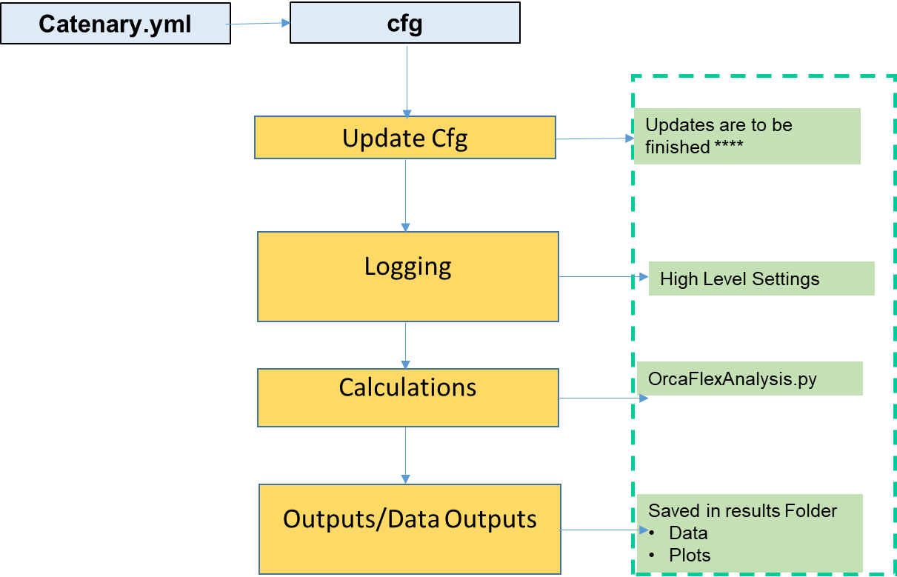

Refer section15: " Dropbox\Engineering\0026 Technical Manuals\0026-ORC-0001-01 Orcaflex Analysis Manual (Draft2).doc".

# Common Code

## Virtual Environment

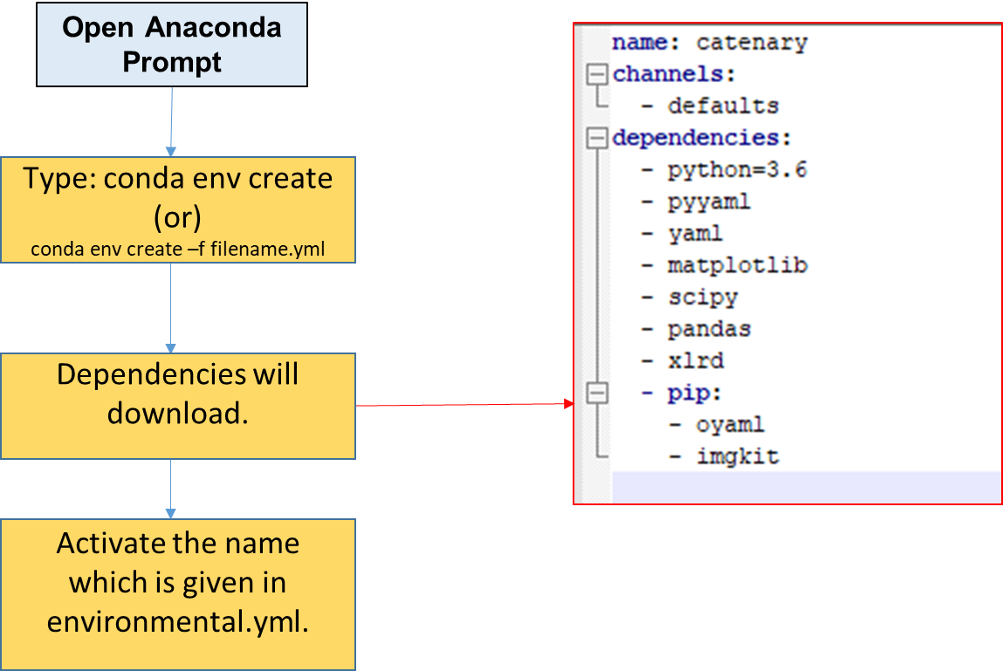

## Program Handling

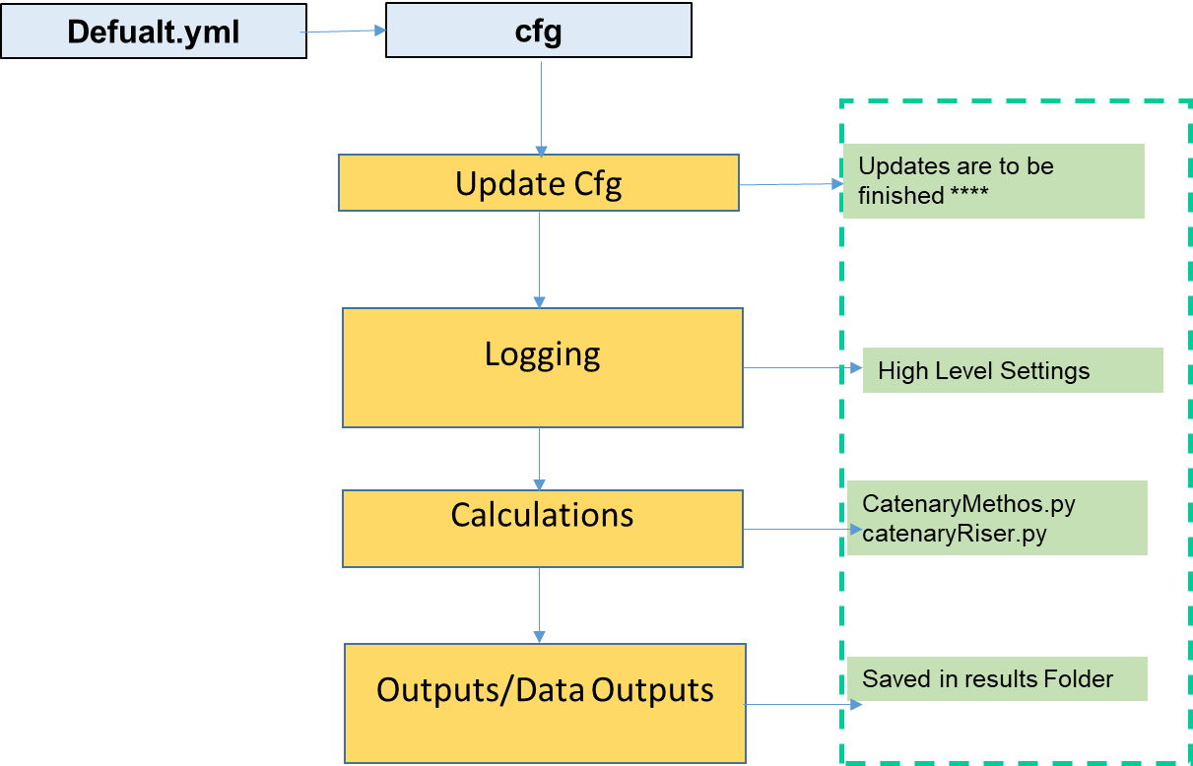

## Set Logging

Objective: To set logging level. logLevels can be 'DEBUG', 'INFO', 'WARNING', 'ERROR', 'CRITICAL‘

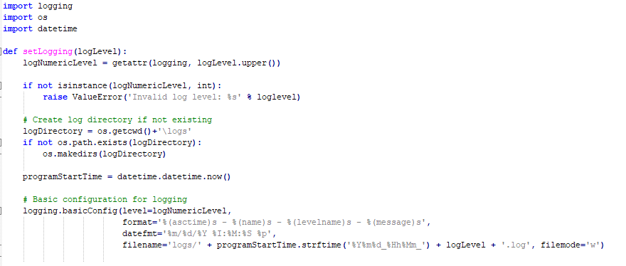

## Yaml

import oyaml as yaml

import collections

from collections import Mapping

def ymlInput(defaultYml, updateYml):

with open(defaultYml, 'r') as ymlfile:

cfg = yaml.load(ymlfile)

if updateYml != None :

# Update values file

try:

with open(updateYml, 'r') as ymlfile:

cfgUpdateValues = yaml.load(ymlfile)

# Convert to logs

# print(cfgUpdateValues)

cfg = update_deep(cfg, cfgUpdateValues)

except:

print("Update Input file could not be loaded successfully. Running program default values")

return cfg

def update_deep(d, u):

for k, v in u.items():

# this condition handles the problem

if not isinstance(d, Mapping):

d = u

elif isinstance(v, Mapping):

r = update_deep(d.get(k, {}), v)

d[k] = r

else:

d[k] = u[k]

return d

## DataFrame to Image

The following code is used to create the image using data frames.

import pandas as pd

import numpy as np

import matplotlib.pyplot as plt

import six

df = pd.DataFrame()

df['date'] = ['2016-04-01', '2016-04-02', '2016-04-03']

df['calories'] = [2200, 2100, 1500]

df['sleep hours'] = [2200, 2100, 1500]

df['gym'] = [True, False, False]

def render_df_table(data, col_width=3.0, row_height=0.625, font_size=14,

header_color='#40466e', row_colors=['#f1f1f2', 'w'], edge_color='w',

bbox=[0, 0, 1, 1], header_columns=0,

ax=None, **kwargs):

if ax is None:

size = (np.array(data.shape[::-1]) + np.array([0, 1])) * np.array([col_width, row_height])

fig, ax = plt.subplots(figsize=size)

ax.axis('off')

mpl_table = ax.table(cellText=data.values, bbox=bbox, colLabels=data.columns, **kwargs)

mpl_table.auto_set_font_size(False)

mpl_table.set_fontsize(font_size)

for k, cell in six.iteritems(mpl_table._cells):

cell.set_edgecolor(edge_color)

if k[0] == 0 or k[1] < header_columns:

cell.set_text_props(weight='bold', color='w')

cell.set_facecolor(header_color)

else:

cell.set_facecolor(row_colors[k[0]%len(row_colors) ])

return ax, fig

def DataFrame_To_Image(df, FileName):

(ax, fig) = render_df_table(df, header_columns=0, col_width=2.0, font_size=8)

fig.savefig('results//' + FileName)

## DataFrame to Xlsx

|  |  |  |
| --- | --- | --- |
| Input | Description | Referance |
| Data Frame to Xlsx | def DataFrame_To_xlsx_xlsxwriter(df, data):  import xlrd  writer = pd.ExcelWriter(data['FileName'], engine='xlsxwriter')  try:  # WorkSheet = wb.get_sheet_by_name(data['SheetName'])  WorkSheet = wb[data['SheetName']]  except:  wb.create_sheet(data['SheetName'])  WorkSheet = wb[data['SheetName']]  df.to_excel(writer, data['SheetName'])  writer.save() | <https://xlsxwriter.readthedocs.io/working_with_pandas.html> |
| Data Frame to Xlsx to Openpyxl | def DataFrame_To_xlsx_openpyxl(df, data):  try:  wb = load_workbook(data['FileName'])  writer = pd.ExcelWriter(data['FileName'], engine = 'openpyxl')  writer.wb = wb  except:  writer = pd.ExcelWriter(data['FileName'])  try:  # WorkSheet = wb.get_sheet_by_name(data['SheetName'])  WorkSheet = wb[data['SheetName']]  except:  wb.create_sheet(data['SheetName'])  WorkSheet = wb[data['SheetName']]  # For xlsxwriter  # WorkSheet = wb.add_worksheet(data['SheetName'])  df.to_excel(writer, data['SheetName'])  writer.save() | <https://stackoverflow.com/questions/42370977/how-to-save-a-new-sheet-in-an-existing-excel-file-using-pandas/42371251>  <https://stackoverflow.com/questions/36814050/openpyxl-get-sheet-by-name> |
| DataFrameArray_To_xlsx_openpyxl | def DataFrameArray_To_xlsx_openpyxl(dfArray, data):  # try:  # # Load existing workbook  # wb = load_workbook(filename = data['FileName'])  # writer = pd.ExcelWriter  # writer.wb = wb  # except:  print("Opening new workbook")  writer = pd.ExcelWriter(data['FileName'], engine = 'openpyxl')  for dfIndex in range(0, len(dfArray)):  dfArray[dfIndex].to_excel(writer, data['SheetNames'][dfIndex])  # property cell.border should be used instead of cell.style.border  # if data['thin_border']:  # ws = wb.active  # thin_border = Border(  # left=Side(border_style=BORDER_THIN, color='00000000'),  # right=Side(border_style=BORDER_THIN, color='00000000'),  # top=Side(border_style=BORDER_THIN, color='00000000'),  # bottom=Side(border_style=BORDER_THIN, color='00000000')  # )  # rows = len(dfArray[dfIndex])+1  # columns = len(dfArray[dfIndex].columns)+1  # ws.cell(row=rows, column=columns).border = thin_border  writer.save()  if __name__ == '__main__':  import numpy as np  df = pd.DataFrame(np.random.random([3, 3]),  columns=['A', 'B', 'C'], index=['first', 'second', 'third'])  data = {"FileName" : "example.xlsx",  "SheetName": 'Sheet1'}  DataFrame_To_xlsx(df, data) | <https://stackoverflow.com/questions/24917201/applying-borders-to-a-cell-in-openpyxl> |

## Line Plot

## Counter Plot

# references

– PROGRAM HISTORY

## Revision History

|  |  |  |
| --- | --- | --- |
| Revision Date | Features |  |
|  |  |  |

Figure 4‑1.Program History

- ERROR LOG

|  |  |  |
| --- | --- | --- |
|  |  |  |
|  |  |  |
|  |  |  |
|  |  |  |

Figure 4‑2.Error Log.

Calculation Errors

The typical errors encountered while running the calculation program are given in this section.

-test cases.

The program got to handle discontinuities as shown in figure below.

Figure 4‑3.Test Cases.